**pwd** stands for **P**rint **W**orking **D**irectory. It prints the path of the working directory, starting from the root.  
pwd is shell built-in command(pwd) or an actual binary(/bin/pwd).  
$PWD is an [environment variable](https://www.geeksforgeeks.org/environment-variables-in-linux-unix/) which stores the path of the current directory.  
This command has two flags.

***pwd -L****: Prints the symbolic path.****pwd -P****: Prints the actual path.*

A)Built-in pwd (pwd):

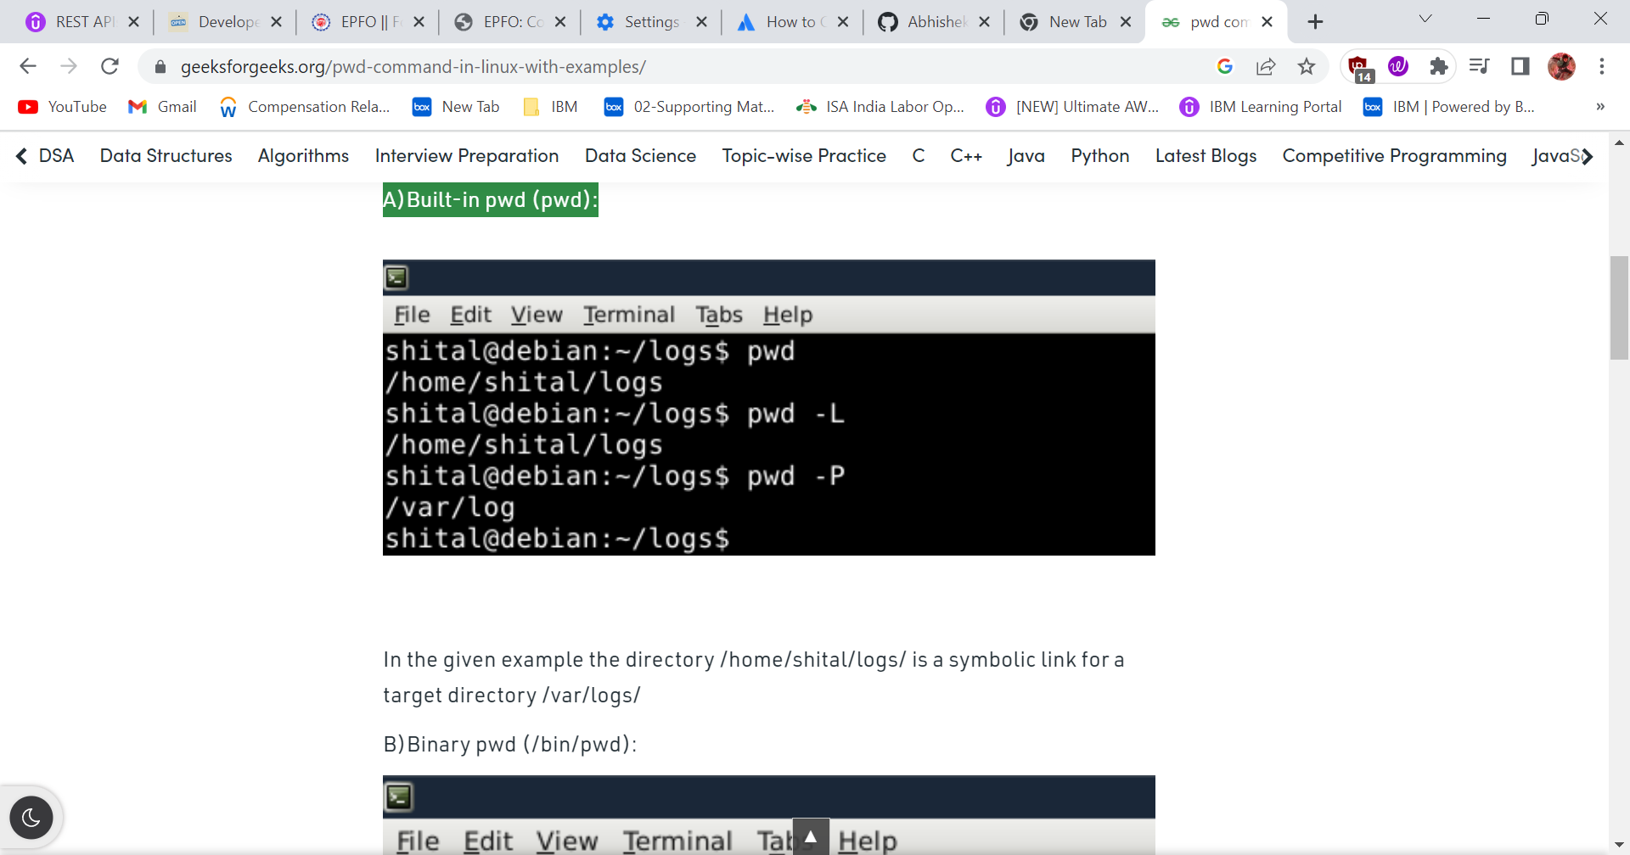

Cd Selenium – Command to jumped you folder

ls – to check in your folder how many files is there .

